**INTEGRATOR USING IC741 OP-AMP**

**LAB # 09**

** Fall 2019**

**Fall 2021**

**CSE202L Circuit system-II**

Submitted by: **Ashfaq Ahmad**

Registration No: **19PWCSE1795**

Class Section: **B**

“On my honor, as student of University of Engineering and Technology, I have neither given nor received unauthorized assistance on this academic work.”

Student Signature: ______________

Submitted to:

**Engr. Faiz ullah**

February 10, 2021

**Department of Computer Systems Engineering**

**University of Engineering and Technology, Peshawar**

**Objective**

To study the operation of the Integrator using op-amp and trace the output wave forms for sine and square wave inputs.

**THEORY:**

This is another application of Op Amp. We can use Op Amplifier as an integrator. If we connect feedback capacitor instead of feedback resistor, than circuit act as an integrator. But here we also connected a feedback resistor. It is because to reduce low frequency gain. Low frequency gain means, if we find gain we divide feedback resistance by input resistance. If we use only capacitor, it has own impedance which is called capacitive reactance and is given by,

Zc=1/2πfc

We know that capacitive reactance of capacitor is inversely propositional to frequency. If we increase frequency then capacitive reactance decrease until it may reach to zero. Similarly if we decrease frequency then capacitive reactance increase until it may reach to infinity. So to limit this variation and to reduce the chance of error in output voltage a feedback resistance is also connected along with capacitor.

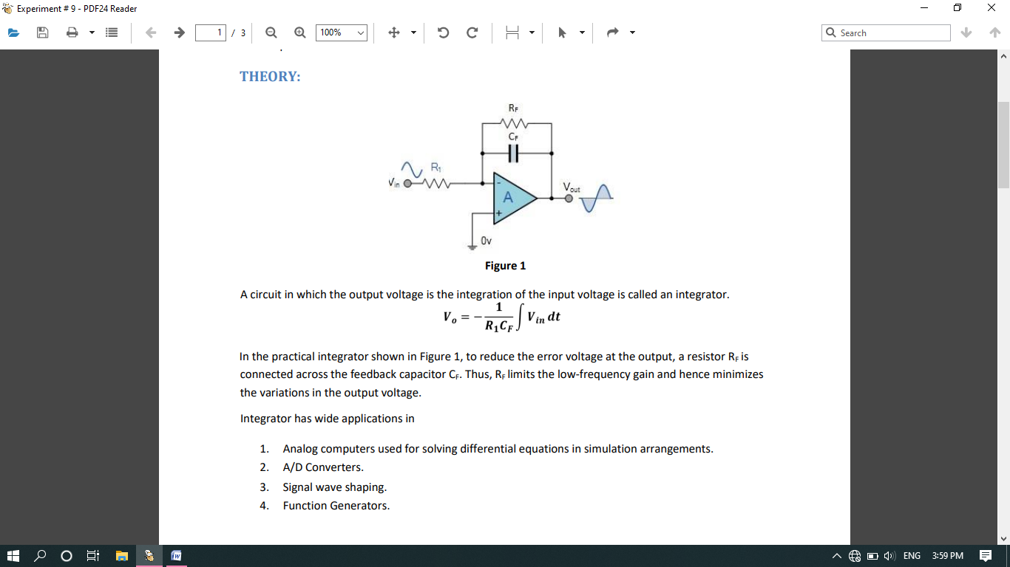

Figure 1

***A circuit in which the output voltage is the integration of the input voltage is called an integrator.***

The voltage of integrator can be calculated as,

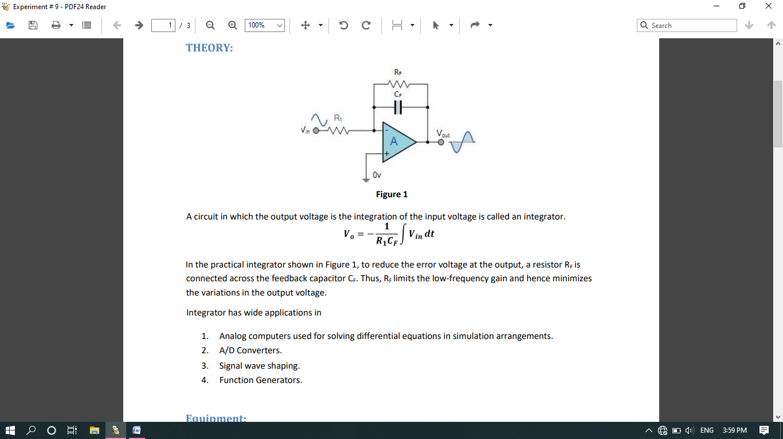

In the practical integrator shown in Figure 1, to reduce the error voltage at the output, a resistor RF is connected across the feedback capacitor CF. Thus, RF limits the low-frequency gain and hence minimizes the variations in the output voltage.

NOTE: if the input signal is sin wave the output signal will be cosine wave with phase difference 90֯. If the input wave is square the output wave will be triangular.

Integrator has wide **applications** in

* Analog computers used for solving differential equations in simulation arrangements.
* Analogue to Digital Converters.
* Signal wave shaping.
* Function Generators.

**Equipment:**

1. Oscilloscope
2. AC Function Generator
3. Digital Multimeter

**Components:**

1. Resistors: 10kΩ, 22kΩ
2. Capacitor 0.1µF
3. Op-amp 741

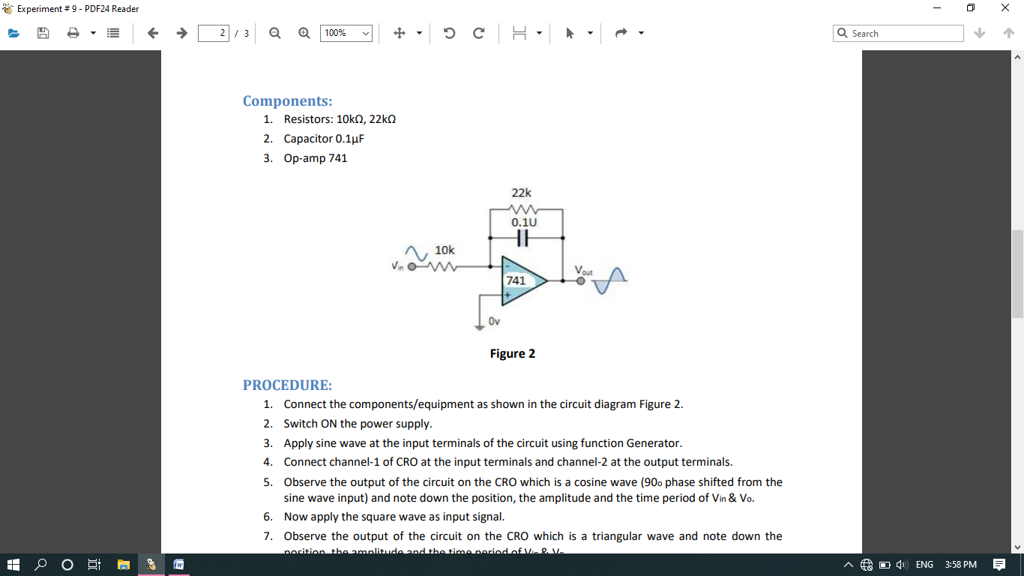

Figure 2

**PROCEDURE:**

1. Connect the components/equipment as shown in the circuit diagram Figure 2.
2. Switch ON the power supply.
3. Apply sine wave at the input terminals of the circuit using function Generator.
4. Connect channel-1 of CRO at the input terminals and channel-2 at the output terminals.
5. Observe the output of the circuit on the CRO which is a cosine wave (90o phase shifted from the sine wave input) and note down the position, the amplitude and the time period of Vin & Vo.
6. Now apply the square wave as input signal.
7. Observe the output of the circuit on the CRO which is a triangular wave and note down the position, the amplitude and the time period of Vin & Vo.
8. Plot the output voltages corresponding to sine and square wave inputs as shown in the Figure 3 below.

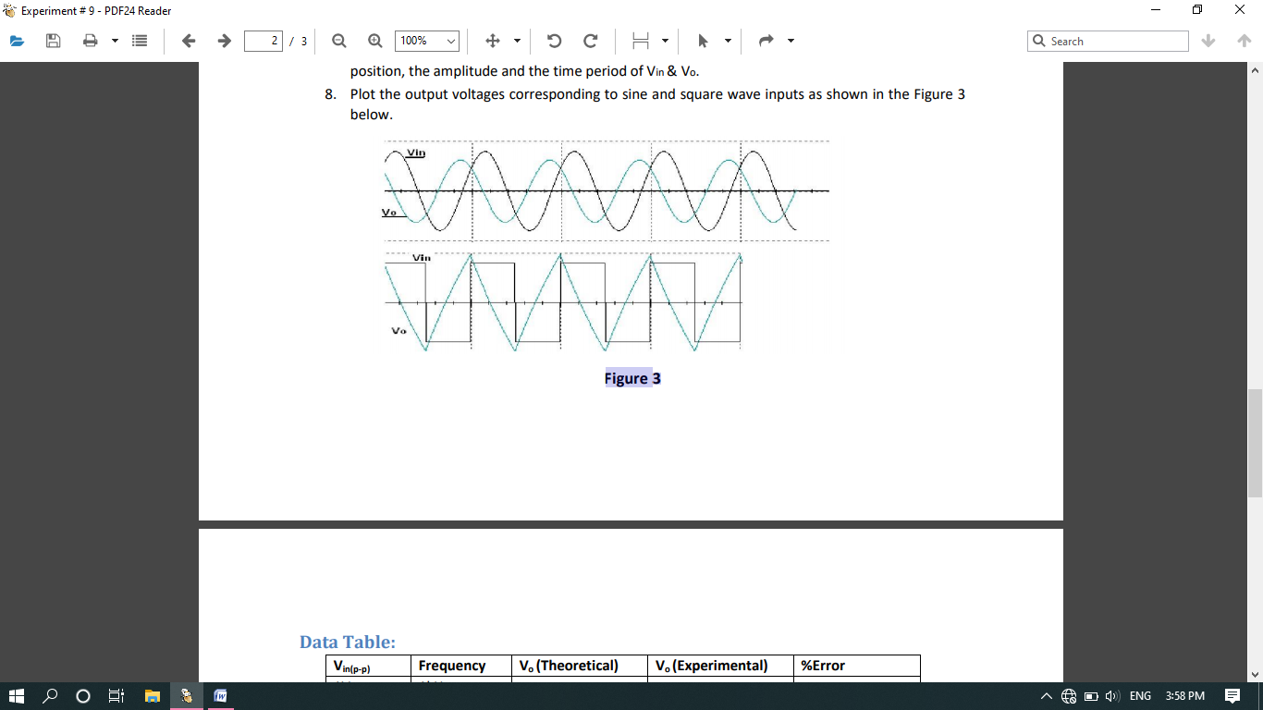

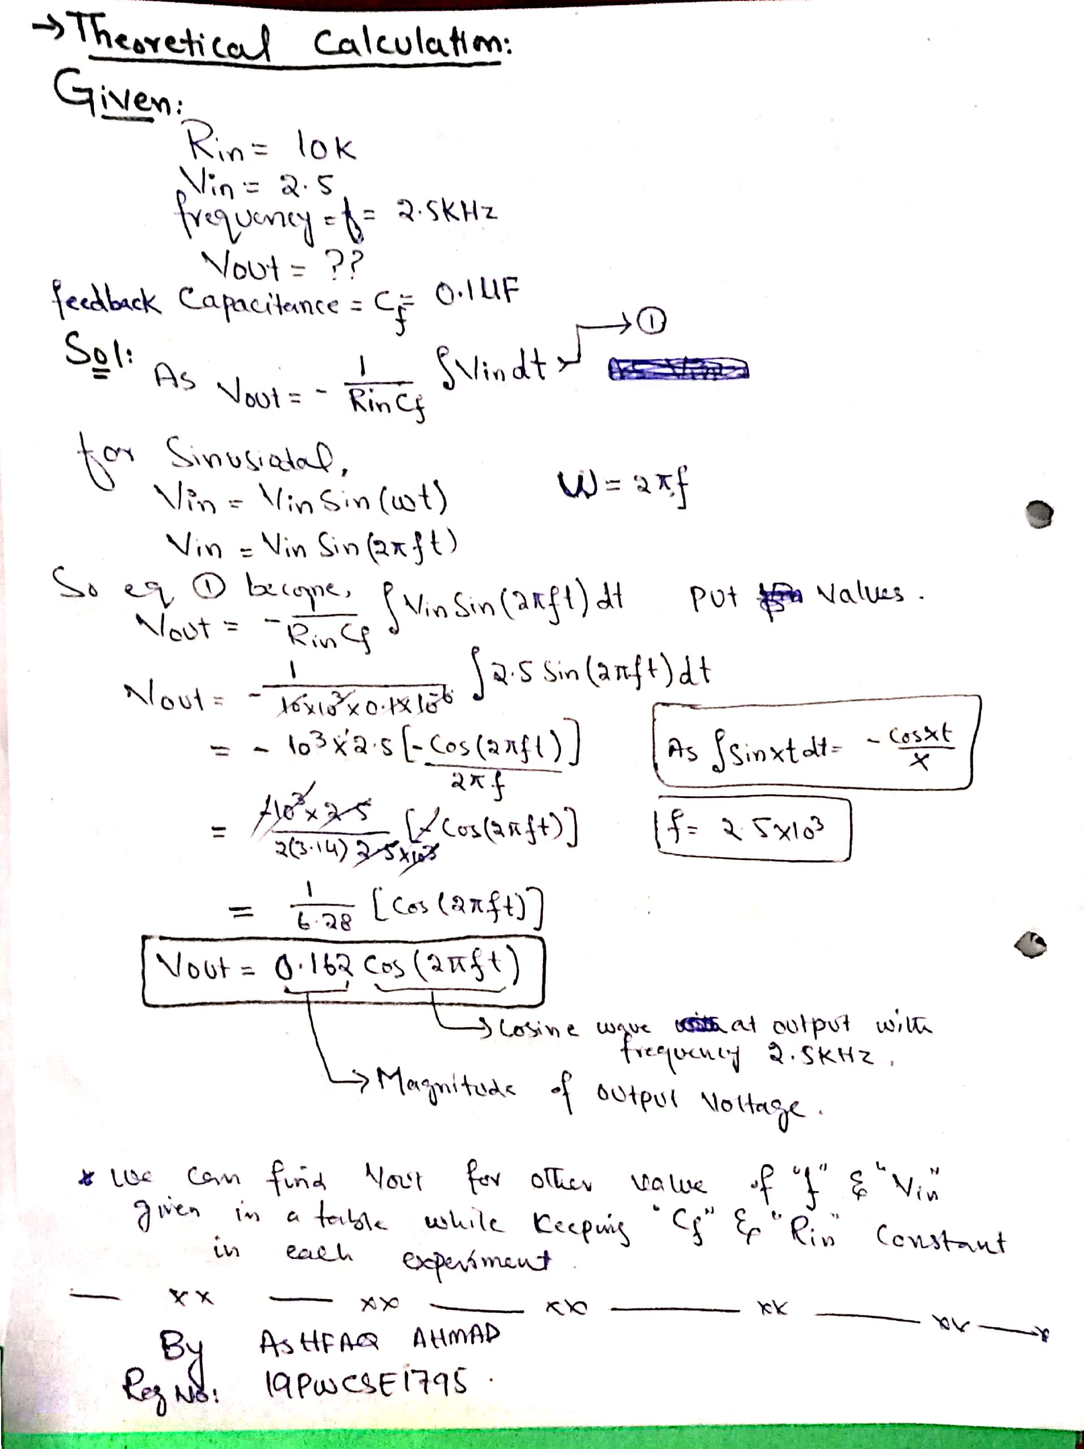

* 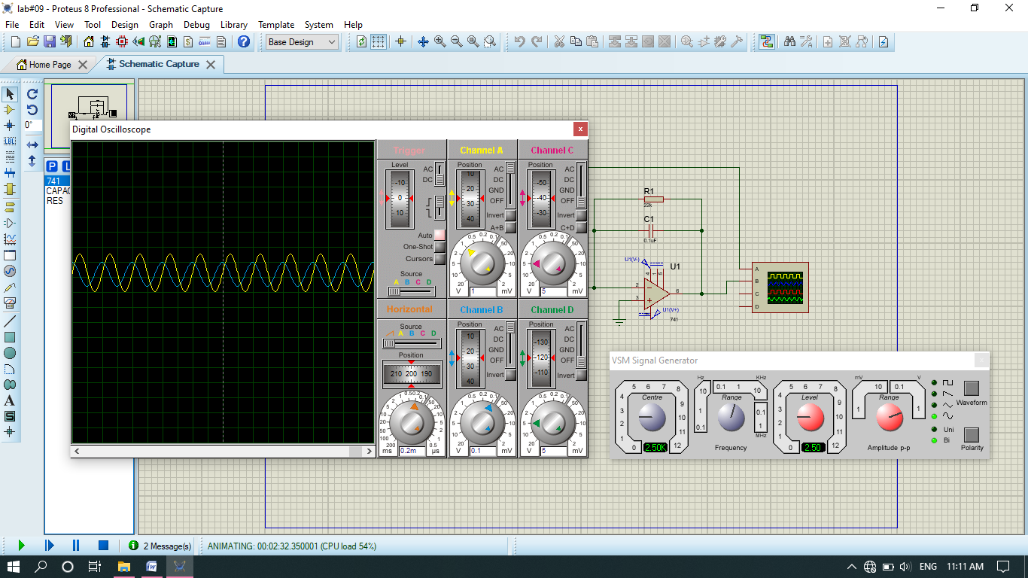**At sinusoidal input output is cosine having phase difference 90 ֯.**
* 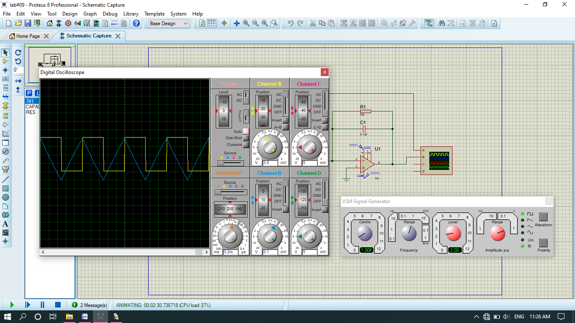**At Square input the output is triangular:**

**Data Table:**

|  |  |  |  |  |
| --- | --- | --- | --- | --- |
| Vin(p-p) | Frequency | Vout theoretical | Vout Experimental | %Error |
| 1V | 1KHz | 0.1591v | 0.150v | 5.6% |
| 2V | 1kHz | 0.318v | 0.310v | 2.5% |
| 1V | 2KHz | 0.0796v | 0.080v | -0.50% |
| 2V | 1.5KHz | 0.212v | 0.211v | 0.47% |
| 2.5V | 2.5KHz | 0.162v | 0.170v | -4.9% |

***THE END***